Department of
Computer Science and Engineering
CSE324 Operating System Lab
Lab Report - 02

- Basic Linux Commands (Part-2)
Topic Name:

Submitted to
Fardowsi Rahman
Lecturer
Department of CSE
Daffodil International University
Submitted by
Name:
ID:
Section: 6_M2
Semester: 7th Semester (Spring 2026)

Remark:
Submission Date: 19/01/2026

Table of Contents
- Introduction 1-1
  - Introduction 1
- Objectives 1-1
  - Objectives 1
- Tools Used 1-1
  - VirtualBox, Ubuntu 1
- Basic Commands 1-9
Commands ls summary 1
4.1.1 Home Directory…..……………………………………………………………………………………………………….1
4.1.2 Root Directory………..……………………………………..…………………………………………………………….2
4.1.3 ls commands……..…………………………………………………………………………………………………………3
4.1.4 clear....…………………………………………………………………………………………………………………………4
4.1.5 pwd 4
4.1.6 cd……………….……………………………………………………………………………………………………………….5
4.1.7 mkdir…….…………………………………………………………………………………………………………………….6
4.1.8 cat…………………….………………………………………………………………………………………………………...7
4.1.9 marge file 8
4.1.10 remove (rm,rmdir)…………….……………………………………………………………………………………...8
4.1.11 Task 01 – multiple folder create 9
- Use Cases and Applications 9-9
  - Use Cases and Applications 9
- Conclusion 10-10
  - Conclusion 10

1. Introduction
Linux is an operating system that allows users to work using commands. These commands are typed in the terminal to manage files and folders. In this lab, we learn some basic Linux commands that help us view files, create folders, move between directories, remove files and merge file.

2. Objectives
The main objectives of this lab are:
- To understand the basic structure of the Linux operating system
- To learn how to use the Linux terminal
- To practice basic Linux commands for file and directory management
- To create, view, delete, and merge files using commands
- To gain hands-on experience using Ubuntu Linux in a virtual environment

3. Tools Used
The following tools were used to perform this lab:
- VirtualBox – A virtualization software used to run Linux as a virtual machine
- Ubuntu Linux – A popular Linux distribution used as the operating system
- Terminal – Command-line interface used to execute Linux commands
- Host Operating System – Windows (for running VirtualBox)
4. Basic Commands
Command ls:
The ls command is used to see the list of files and folders in a directory.
- ls shows normal files
- ls -l shows files in long format (details)
- ls -a shows hidden files
- ls -al shows hidden files with details
- ls -ls shows file size
- ls -lt shows files with time and date

Home Directory (cd):
The Home directory is the personal folder of a user in Linux.Each user has a separate home directory where personal files, documents, downloads, and settings are stored.
For example, the home directory path of a user is:
/home/username
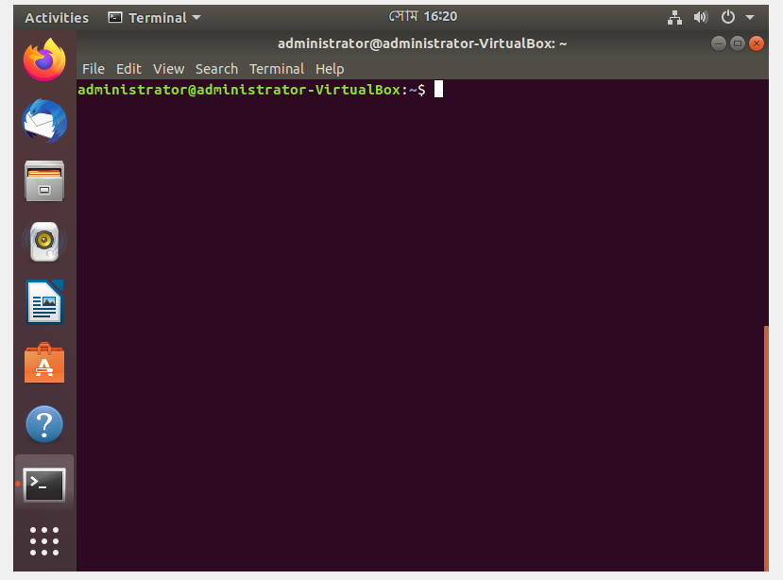
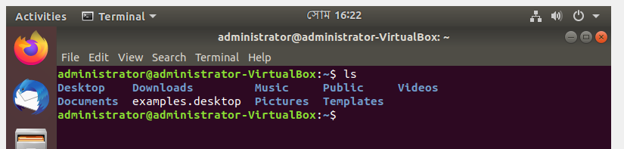

Root Directory (cd /)
The root directory is the top-most directory in the Linux file system hierarchy.
It is represented by a single slash:
- Go to Root Directory: cd /
Description:
The cd / command is used to move to the root directory of the Linux file system. The root directory (/) is the top-level directory that contains all other system directories such as /bin, /etc, /home, and /usr.
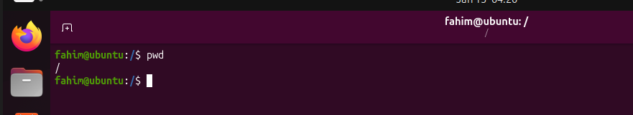
- List Contents of Root Directory: ls /
Description:
The ls / command is used to display the list of all files and directories present in the root directory. It shows major system folders such as /bin, /etc, /home, /lib, /usr and others.
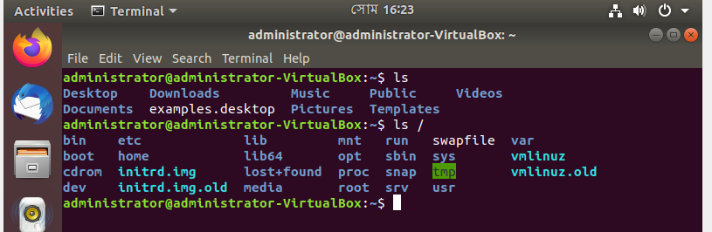
Long folder (ls -l)
Description:
The command ls -l is used to list files and directories in long format.
It shows detailed information such as permissions, number of links, owner, group, size, and last modified date.
This helps the user understand file properties easily.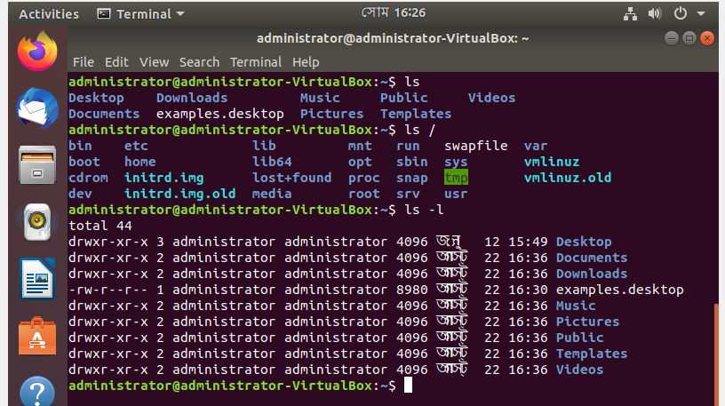
Hidden file (ls –a)
Lists all files including hidden files that start with a dot (.).
Description:
The ls -a command displays all files and directories, including hidden files. Hidden files in Linux start with a dot (.), such as .bashrc or .profile.
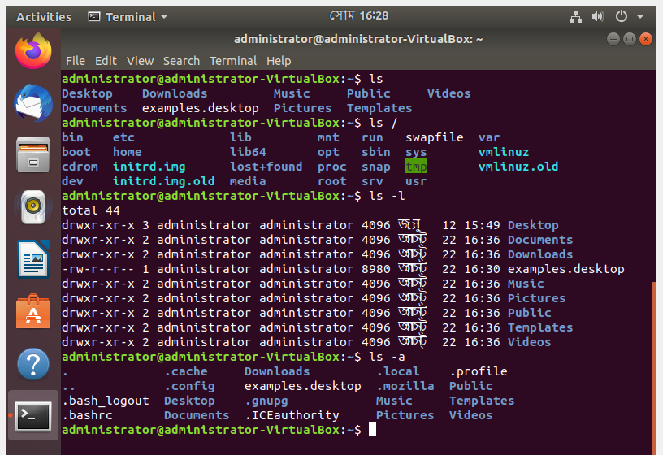
Hidden file with details (ls –al)
Description:
The command ls -al is used to list all files and directories, including hidden ones, in the current directory.
It also shows detailed information like permissions, owner, group, size, and modification date.
This is useful for viewing complete directory details at a glance.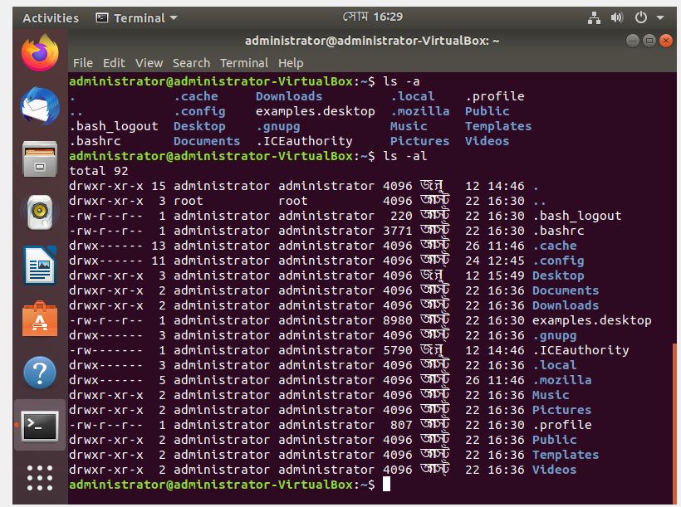
File size (Memory) (ls –ls)
Description:
The ls command is used to list files and directories in the current directory.
It shows only the names of files and folders by default.
This command helps the user see the contents of a directory quickly.
- l → long listing format
- -s → file size in blocks
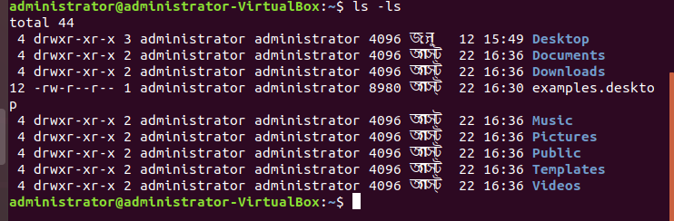

Time-wise sorting (Time) (ls –lt)
Description:
The ls -lt command lists files and directories in long format and sorts them by modification time. The most recently modified files and directories appear first in the list.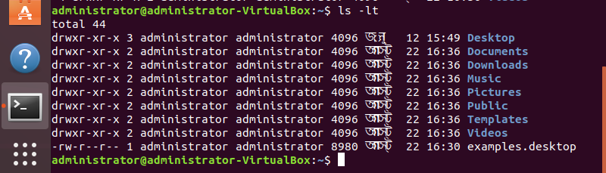
Clear all commands (clear)
Clears all previous commands and outputs from the terminal screen.
Description:
The clear command is used to remove all previous commands and outputs from the terminal screen, providing a clean and fresh workspace.
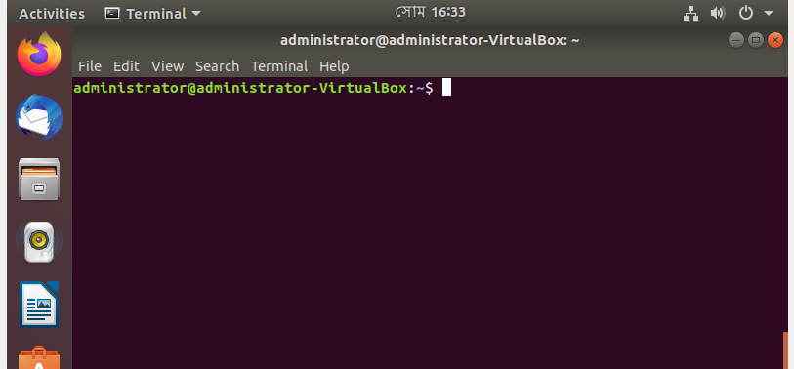
Shows current working directory (pwd)
Description:
The pwd command displays the full path of the current directory, showing the exact location where the user is currently working in the file system.
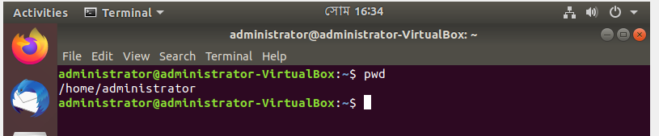

Changes the current directory(cd)
The cd command is used to change directories.
- cd goes to home directory: cd
Description:
The cd command followed by a directory name is used to go to that specific directory. For example, cd Desktop moves the user from the current location to the Desktop folder, helping navigate the file system easily.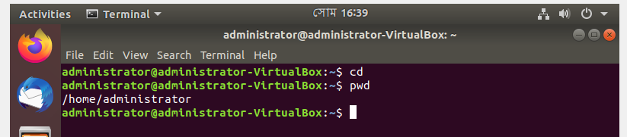
- cd (Directory Name) goes to another Directory: cd Desktop
Description:
The cd (Directory Name) command is used to change the current directory to the specified folder. For example, cd Desktop moves the user from the current location to the Desktop directory, allowing navigation through the file system.
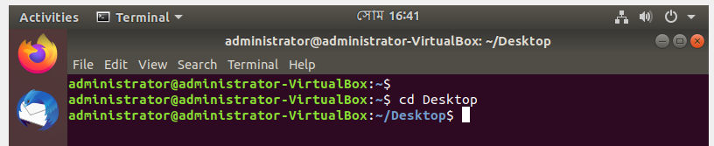
- cd .. goes one step back
- cd / goes to root directory
Description:
The cd / command is used to go to the root directory of the file system. It moves the user to the top-most level, from where all other directories branch out.
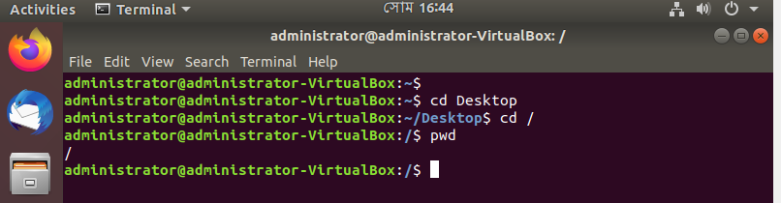

- cd - goes to previous directory: cd –
Description:
The cd - command is used to switch to the previous directory you were in. It allows quick navigation back and forth between two directories.
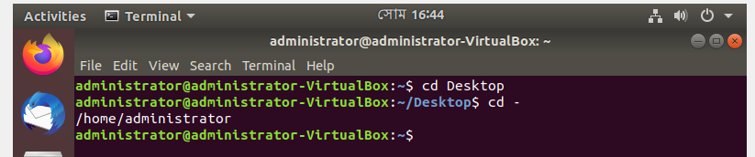
- cd -- stops option processing: cd –
Description:
The cd -- command is used to treat any following argument as a directory name, even if it starts with a -.
It helps avoid confusion when directory names look like options or flags.
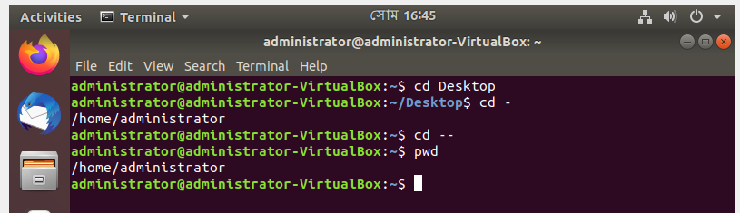
Make directory (mkdir)
Description:
The mkdir command is used to create a new directory in the file system.
For example, mkdir Project will create a folder named Project in the current location.
It helps organize files by keeping them in separate directories.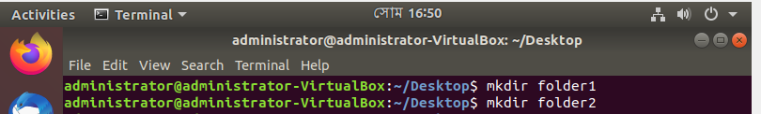
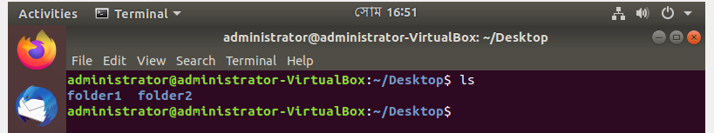

Display the contents (cat)
Description:
The cat command is used to display the contents of a file on the terminal.
It can also combine multiple files or create new files quickly.
For example, cat file.txt shows the content of file.txt.(saving using ctrl+D)
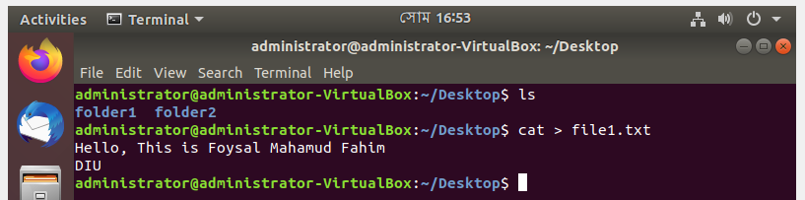
The cat file_name command is used to view the content of a file.
Description:
The command cat file1.txt is used to display the contents of file1.txt on the terminal.
It allows the user to read the file quickly without opening an editor.
This command is useful for viewing small text files directly in the console.
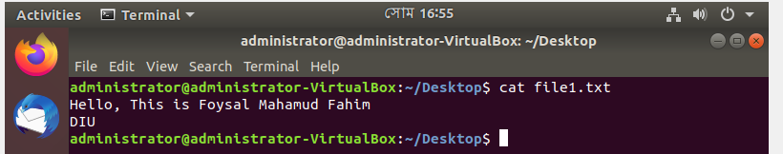
The cat >> file_name command is used to add the content of a file.
Description:
The command cat >> file1.txt is used to append text to the end of file1.txt.
After running it, you can type new content, and it will be added to the file.
Pressing Ctrl + D ends the input and saves the appended text.
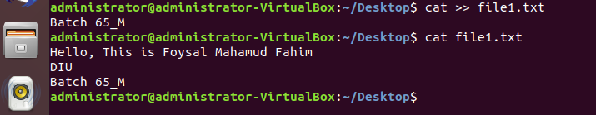
The cat -n file_name command is used to line number of a file.
Description:
The command cat -n file1.txt is used to display the contents of file1.txt with line numbers.
It helps the user see each line’s position in the file.
This is useful for referencing or debugging specific lines in a text file.
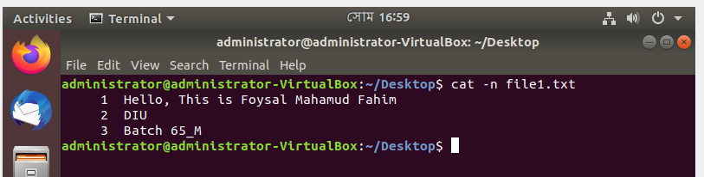

Merge 2 file: Combines the contents of multiple files and saves them into a new file.
Description:
The command cat file1.txt file2.txt > newfile.txt is used to combine the contents of file1.txt and file2.txt into a new file named newfile.txt.
If newfile.txt already exists, its content will be overwritten.
This is useful for merging multiple files into one.
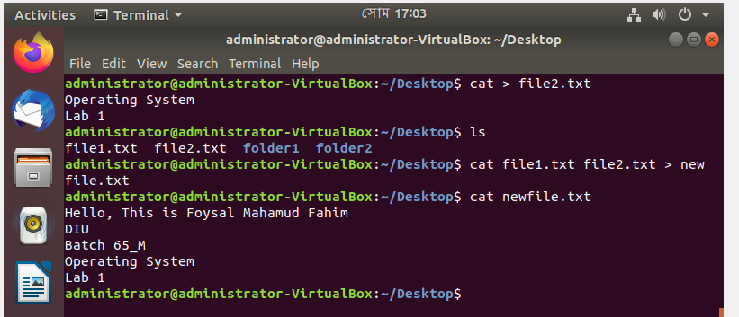
Remove file (rm)
Description:
The rm command is used to delete files or directories from the file system.
For example, rm file1.txt will remove the file named file1.txt permanently.
It is a quick way to clean up unwanted files, but deleted files cannot be recovered easily.
Once deleted using rm, files cannot be recovered easily, so it should be used carefully.
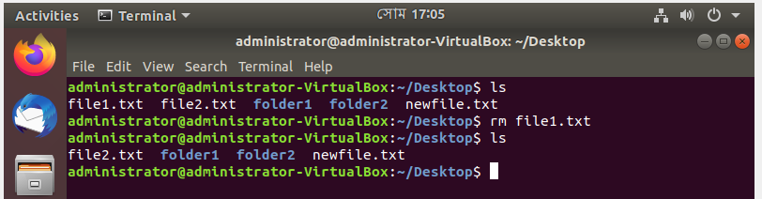
Remove empty folder (rmdir)
Description:
The rmdir command is used to delete empty directories from the file system.
For example, rmdir Project will remove the directory named Project if it contains no files.
It is useful for cleaning up unused or empty folders.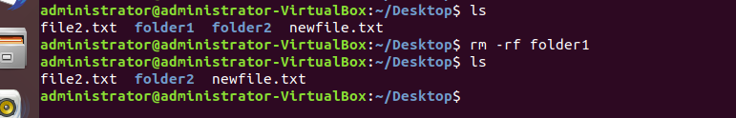
Remove folder (rm -rf)
Description:
The command rm -rf is used to forcefully and recursively delete files and directories.
It can remove a directory along with all its contents, including subdirectories and files.
This command is powerful and dangerous, so it should be used carefully.
Task 01: Create multiple folder (mkdir -p a/b/c)
Parent- a, child-b,
parent-b, child-c
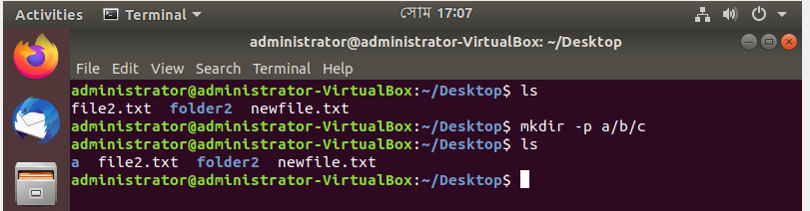
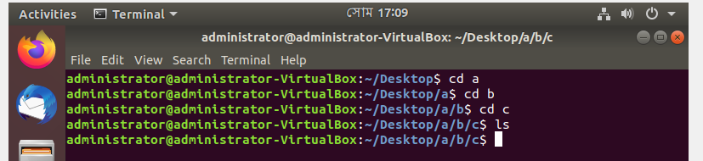

5. Use Cases and Applications
Linux commands and the Linux operating system are widely used in various real-world scenarios. Some common use cases and applications include:
- Server Management – Linux powers web servers, database servers, and cloud infrastructure due to its stability and security.
- System Administration – File management, user management, and automation tasks are performed using Linux commands.
- Cybersecurity – Penetration testing, network monitoring, and security auditing are often conducted in Linux environments.
- Software Development – Developers use Linux for compiling programs, running scripts, and managing source code repositories.
- Data Analysis and Machine Learning – Linux supports tools and libraries for big data processing and AI/ML development.
6. Conclusion
In this lab, we learned the fundamental commands of Linux, including file and directory management, viewing hidden files, creating and removing directories, and merging file contents. We explored both the Home directory, which stores personal user data, and the Root directory, which contains system files. Practical exercises with commands like ls, mkdir, cat, rm, rmdir, and rm -rf helped us understand how to navigate the Linux file system efficiently.

